3rd IDSS Abstract Title

**Author name**

This is a sample document format for the max. 1500 characters abstract, for submissions to **3rd** **IDSS -** **Interdisciplinary Doctoral School Seminar**. This document is provided in Microsoft Word and Adobe PDF format. **For abstract text fonts: use only 10pt Calibri or Arial font** (roman, **bold** or *italic*), and Symbol.

Simple equations should be included in-line wherever possible, whereas more complex expressions should be centred and numbered if there are several. Figures should be relevant to the submission and preferably centred as shown below. They should be placed as close as possible to where they are mentioned in the text. Placing subfigures side-by-side is a convenient way to include multiple results within the one page limit. The figures can be provided in greyscale or colours. Figure captions should be centred beneath figures and in an 8-point font.

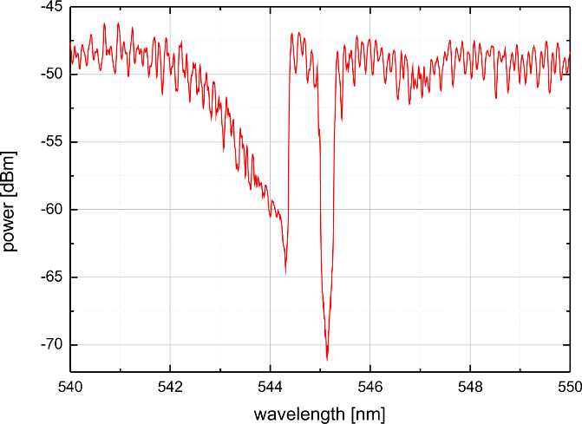

**Fig. 1** Short figure caption.

Abstract should be uploaded on the IDSS website however, we still ask you also to upload a plain text during the submission.